Add detailed item information in MPP via ‘Select options’

- Press the button ‘Select-options’:
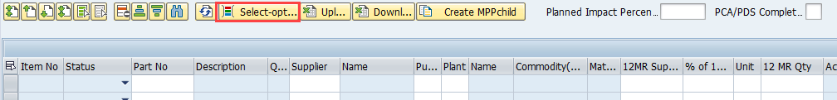

- Enter suitable search criteria (details in the table below):
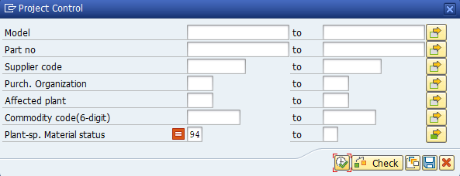

Field | Explanation
Model | Not in use
Part no | Part number
Supplier code | Vendor Parma number
Purch. Organization | Purchasing Organization
Affected plant | Plant code
Commodity code (6-digit) | 6 digit sub-commodity code
Plant-sp. Material status | Plant-specific material status  Status 94+95 excluded by default (changeable)

- When all information is entered, press to execute

- The information from the file will be displayed like below and a confirmation message will appear in the status bar at the bottom of the screen:
